**Ex 9 :**

**ListofPlayers.js**

import React from 'react';

const ListofPlayers = () => {

const players = [

{ name: 'Rohit', score: 85 },

{ name: 'Gill', score: 45 },

{ name: 'Kohli', score: 95 },

{ name: 'Rahul', score: 30 },

{ name: 'Iyer', score: 77 },

{ name: 'Hardik', score: 88 },

{ name: 'Jadeja', score: 66 },

{ name: 'Bumrah', score: 50 },

{ name: 'Shami', score: 28 },

{ name: 'Siraj', score: 72 },

{ name: 'Kuldeep', score: 80 },

];

const lowScorers = players.filter(player => player.score < 70);

return (

<div>

<h2>All Players</h2>

<ul>

{players.map((p, i) => (

<li key={i}>{p.name} - {p.score}</li>

))}

</ul>

<h3>Players with score less than 70</h3>

<ul>

{lowScorers.map((p, i) => (

<li key={i}>{p.name} - {p.score}</li>

))}

</ul>

</div>

);

};

export default ListofPlayers;

**IndianPlayers.js**

import React from 'react';

const IndianPlayers = () => {

const oddTeam = ['Rohit', 'Kohli', 'Hardik', 'Bumrah', 'Siraj'];

const evenTeam = ['Gill', 'Rahul', 'Iyer', 'Jadeja', 'Shami', 'Kuldeep'];

const [captain, viceCaptain, ...others] = oddTeam;

const T20players = ['Surya', 'Samson', 'Rinku'];

const ranjiPlayers = ['Unadkat', 'Sarfaraz', 'Baba Aparajith'];

const allPlayers = [...T20players, ...ranjiPlayers];

return (

<div>

<h2>Odd Team</h2>

<p>Captain: {captain}</p>

<p>Vice-Captain: {viceCaptain}</p>

<p>Other Players: {others.join(', ')}</p>

<h2>Even Team</h2>

<p>{evenTeam.join(', ')}</p>

<h2>Combined Players (T20 + Ranji)</h2>

<ul>

{allPlayers.map((p, i) => (

<li key={i}>{p}</li>

))}

</ul>

</div>

);

};

export default IndianPlayers;

**App.js**

import React from 'react';

import ListofPlayers from './ListofPlayers';

import IndianPlayers from './IndianPlayers';

function App() {

const flag = true;

return (

<div style={{ padding: '2rem' }}>

<h1>Welcome to Cricket App</h1>

{flag ? <ListofPlayers /> : <IndianPlayers />}

</div>

);

}

export default App;

**Output :**

**Flag = true**

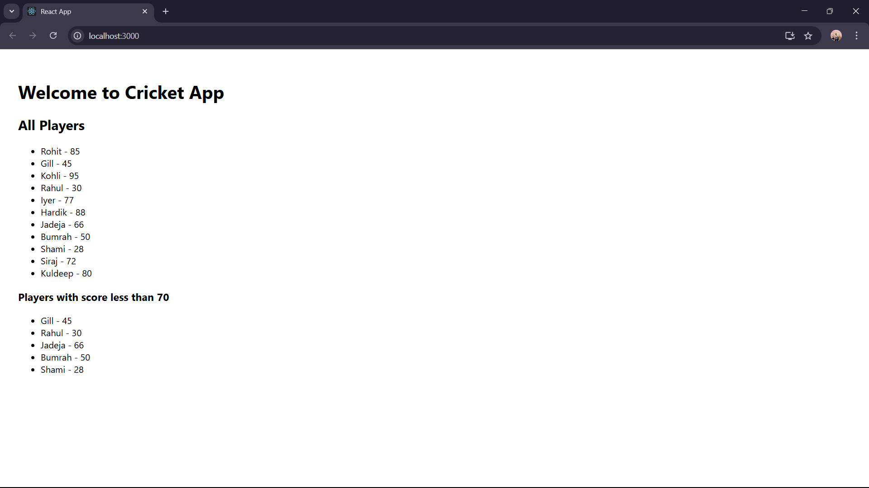

**Flag = false**

